
PANEL ASSESSMENT BRIEFING REPORT
HUNTER AND CENTRAL COAST REGIONAL PLANNING PANEL

PANEL REFERENCE & DA NUMBER | PPSHCC-255 - PAN-377087 – DA/2036/2023
PROPOSAL | Alterations and additions – Educational Establishment & Includes Demolition
ADDRESS | Lot 1 DP530125 458-468 Main Road, Noraville NSW 2263
APPLICANT | Trustee of the Roman Catholic Church for the Diocese of Broken Bay C/- DFP Planning
OWNER | Trustee of the Roman Catholic Church for the Diocese of Broken Bay
DA LODGEMENT DATE | 6 November 2023
APPLICATION TYPE | Integrated Development Application – Bushfire Prone Land – Special Fire Protection Purpose
REGIONALLY SIGNIFICANT CRITERIA | Clause 5, Schedule 6 of the SEPP Planning Systems: Private Infrastructure and community facilities over $5 Million
CIV | $9,286,000 (excluding GST)
CLAUSE 4.6 REQUESTS | N/A
LIST OF ALL RELEVANT PLANNING CONTROLS (S4.15(1)(A) OF EP&A ACT) | - SEPP (Planning Systems) 2021  - SEPP (Resilience and Hazards) 2021  - SEPP (Biodiversity and Conservation) 2021  - SEPP (Transport and Infrastructure) 2021  - Central Coast Local Environmental Plan 2022  - Central Coast Development Control Plan 2022
TOTAL & UNIQUE SUBMISSIONS | One – Objection - extent of written notification, length of notification period.
KEY ISSUES | Preliminary Assessment Not Complete
DOCUMENTS SUBMITTED FOR CONSIDERATION | The Statement of Environmental Effects identifies the following reports and details submitted in support of the Development Application:  - Survey (prepared by Clarke Dowdle & Associates);  - Arborist Report (prepared by Advanced Treescape Consulting);  - Architectural Plans (prepared by Glendenning Szoboszlay Architects);  - Architectural Design Statement (prepared by Glendenning Szoboszlay Architects);  - Landscape Plans (prepared by iScape Landscape Architecture);  - Acoustic Assessment (prepared by JHA);  - Preliminary Site Investigation (prepared by EBG Environmental Geoscience);  - Traffic Impact Assessment (prepared by Traffix);  - Stormwater & Civil Plans (prepared by Jones Nicholson);  - Accessibility & BCA Assessment (prepared by Accessed);  - Geotechnical Assessment (prepared by Crozier Geotechnical Consultants);  - Bushfire Assessment (prepared by Building Code & Bushfire Hazard Solutions);  - Waste Management Plan (prepared by MRA Consulting Group);  - Acid Sulfate Soils Assessment Report (prepared by EBG Environmental Geoscience);  - Cost Estimate Report (prepared by Wilde and Woollard);  - Ecology Report (prepared by AEP);  - Flood Impact Assessment (prepared by Jones Nicholson); and  - Plan of Management (prepared by St Mary’s Toukley Catholic Primary School).
PLAN VERSION | 23 November 2023 Version No. 02
PREPARED BY | N Burr
DATE OF REPORT | 18 September 2024

EXECUTIVE SUMMARY

The subject development application, DA/2036/2023, seeks consent for the alterations and additions to St Mary’s Primary School at No. 458-468 Main Road, Noraville. Specifically, the proposed development includes the following:

- Demolition works;

- Extension of a classroom building (creating Block J);

- Refurbishment of a classroom building (Block I), including the creation of a withdrawal room between two existing General Learning Areas (GLAs);
- Refurbishment and expansion of an administration building (existing Block D) which will be known as Block L;

- Refurbishment of a classroom building (Block C);

- Refurbishment of an amenities building (Block B);

- The construction of a covered outdoor learning area (COLA) and covered walkway adjacent to Block C;

- Landscaping works, fencing and the removal of eight (8) trees; and

- Stormwater management works.

- An increase in students from 540 to 630.

Subject site is legally described as Lot 1 DP530125 at No. 458-468 Main Road, Noraville. The site is located on the northern side of Main Road and has an area of 5.35ha.

Existing development on the site comprises an existing place of public worship and a primary school which has evolved on the site since the 1970’s resulting in an eclectic mix of building styles and ages. The site is access va Main Road and has provision on site for buses and 130 car parking spaces. Pedestrian access via Main Road is serviced by footpaths and signalised crossing.

The site is partly zoned R2 – Low Density Residential and partly zoned C2 – Environmental Conservation zone under the Central Coast Local Environmental Plan 2022. The development is wholly occurring in the R2 zoned portion of the site and Educational Establishments are permissible with consent.

The principle planning controls relevant to the proposal include State Environmental Planning Policy (Transport and Infrastructure) 2021, Central Coast Local Environmental Plan 2022 and Central Coast Development Control Plan 2022.

The proposal is consistent with various provisions of the planning controls including:

- The proposal is considered to comply with the various objects of the EP&A Act (orderly and economic development of land) and is not contrary to the public interest given it is consistent with various planning controls.
- The proposal also complies with the matters for consideration under Section 4.15(1) of the EP& A Act in relation to potential impacts to surrounding area.

The application is integrated development pursuant to Section 4.46 of the Environmental Planning and Assessment Act 1979 (‘EP&A Act’). A referral to NSW Rural Fire Service pursuant to Rural Fires Act 1997 was sent and RFS have issued General Terms of Approval (GTAs) subject to conditions.

The application was exhibited from 24 November 2023 to 18 December 2023 with one submission being received raising concern with the extent of the notification and the length of the period allowed for public submissions.

The application is referred to the Hunter and Central Coast Regional Planning Panel (‘the Panel’) as the development is ‘regionally significant development’, pursuant to Section 2.19(1) of State Environmental Planning Policy (Planning Systems) 2021 as the proposal is development for an educational establishment with a CIV over $5 million.

A kick off briefing was held with the Panel on 16 January 2024, where key issues were discussed including flood hazards, removal of trees and previous consents issued in relation to the site.

The key issues associated with the proposal include:

- Traffic and Car Parking – The proposed development complies with the required number of parking spaces resulting from the increase student and staff numbers. TfNSW and Council’s expert have reviewed the anticipated impacts on the local road network and found the impact associated with the development to be acceptable. There is a plan of management provided by the applicant to address the use of the parking and access by the different uses on the site.

- Bushfire – The NSW RFS have issued General Terms of Approval with respect to the development and the bushfire mitigation measures do not result in any undue environmental or ecological impacts.

- Flooding – The development has been design to sit above the PMF and a safe low hazard evacuation route has been identified to ensure the development may be safely occupied without any undue economic or ecological risk.

- Tree Removal – The proposed is considered to have avoided undue tree removal and the tree removal proposed is offset by the provision of landscaping.

Following a detailed assessment of the proposed development, pursuant to Section 4.16(1)(b) of the Environmental Planning and Assessment Act, DA/2036/2023, is recommended for approval, subject to the recommended conditions contained in Attachment A of this Report.

THE SITE AND LOCALITY

Subject site is legally described as Lot 1 DP530125 at No. 458-468 Main Road, Noraville. The site is located on the northern side of Main Road and has an area of 5.35ha and is currently occupied by an existing educational establishment – St Marys Catholic School (refer to Figure 1).

The site is zoned R2 Low Density residential and C2 Environmental Conservation pursuant to the Central Coast Local Environmental Plan 2022 (the LEP). The site is not a heritage item but is subject to development standards under the LEP of a maximum building height of 9.5m and a maximum Floor Space Ratio (FSR) of .05:1. The LEP also identifies the site as being subject to class 5 Acid Sulfate Soils.

The site is bushfire prone land, subject to flooding, contains a coastal wetland, a coastal wetland buffer area and vegetation identified on the biodiversity values mapping.

The site contains an existing place of public worship and primary school. The Statement of Environmental Effects provides the following description of the church activities:

[The] Church has a capacity of 500 seats. Mass times occur at 9am on Monday to Thursday and at 9:15am on Friday mornings. Mass typically takes places for a short period of time during the week (approximately 30 minutes). On weekends, there are morning and evening services that take place which are the peak services for the Church. Funerals take place occasionally during the week and are typically held between 10am and 2:30pm. Access is from Main Road and 133 car parking spaces are provided on site.

And in relation to the existing school:

There are currently 540 students attending the School and 49 staff that work in a variety of full-time, part-time, support and administrative roles. Also located within the boundaries of the School is an Aspect Central Coast school that has an enrolment of 20 students and four staff. The Aspect School provides for dynamic and individualised learning for students on the autism spectrum.

The site slopes northeast and has an overland flowpath through the central area of the site with a vegetated wetland and drainage along the eastern boundary and the northern portion of the site. The existing school is generally arranged along the western boundary outside the central drainage corridor.

The surrounding neighbourhood is generally characterised by low density residential dwellings in one or two storey construction.

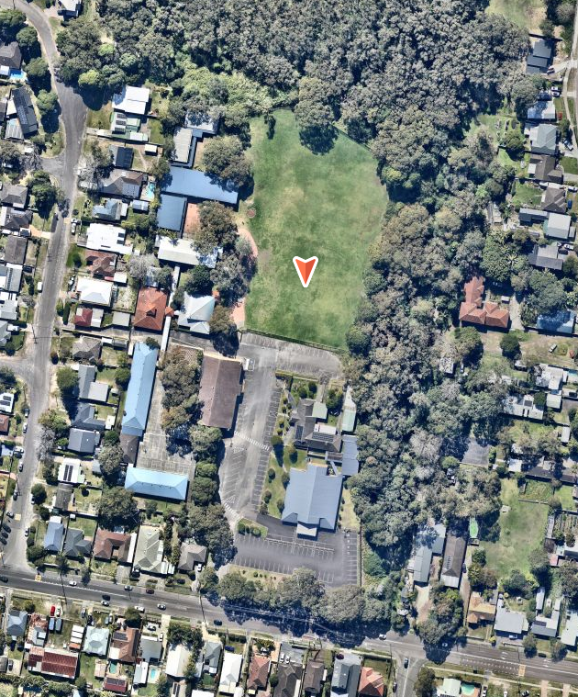
Figure 1: Aerial view of subject site Nearmap dated 12 August 2023

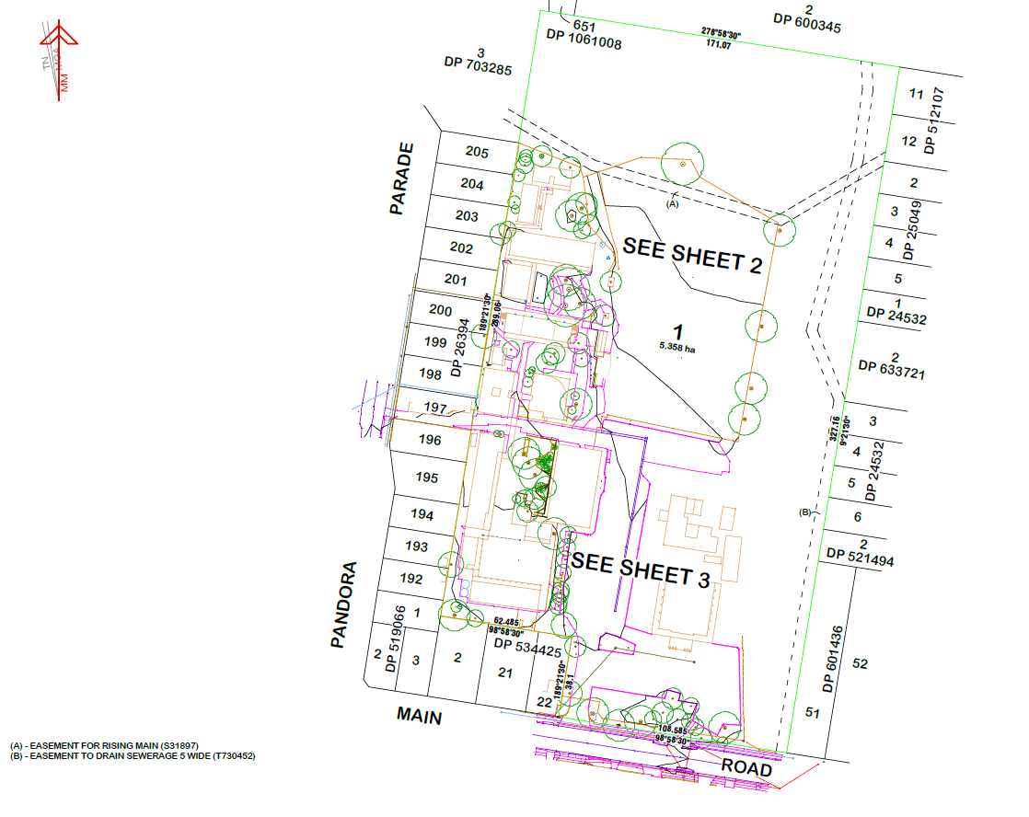
Figure 2. Survey Plan, Clarke Dowdle & associates.

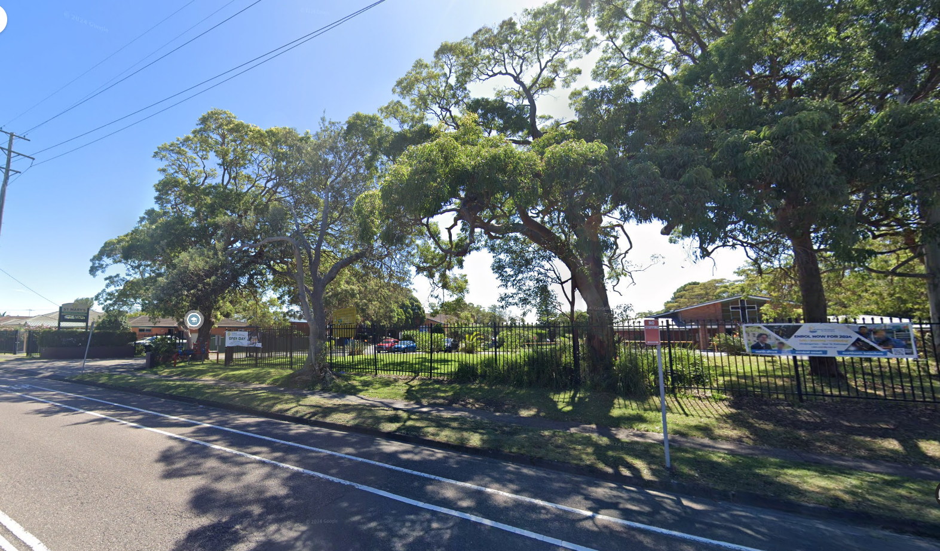
Figure 3. View Northwest from Main Road – Streetview

THE PROPOSAL AND BACKGROUND

The development application seeks consent for both the demolition and construction of building works as follows:

The proposed development comprises:

- Demolition works;

- Extension of a classroom building (creating Block J);

- Refurbishment of a classroom building (Block I), including the creation of a withdrawal room between two existing General Learning Areas (GLAs);

- Refurbishment and expansion of an administration building (existing Block D) which will be known as Block L;

- Refurbishment of a classroom building (Block C);

- Refurbishment of an amenities building (Block B);

- The construction of a covered outdoor learning area (COLA) and covered walkway adjacent to Block C;

- Landscaping works, fencing and the removal of eight (8) trees; and

- Stormwater management works.

Demolition and Site Preparation
The proposed works involves minor internal and external demolition works to existing classroom and administrative buildings.
To facilitate the construction of Block J, minor earthworks are proposed as the building is raised and comprises an undercroft area beneath the first-floor level. There are also minor earthworks associated with the landscaping and the provision of accessible compliant walkways in and around the undercroft area.
A storage shed (Block E) is also proposed to be demolished to facilitate the extension of the Admin/Staff building.
Construction Works
New Block J
The new Block J will comprise an undercroft area on the ground level that will include a range of artificial turf and concrete surfaces. Tiered seating and accessible walkways are also proposed as the land slopes down towards the existing grassed sports field. A concrete ‘Stage Area’ is also proposed at the bottom of the tiered seating.
A lift and accessible toilet spaces are proposed adjacent to existing girls and boy’s toilets on the ground floor of Block F.
The first-floor level of proposed Block J will comprise six GLAs and an unenclosed shared learning space. Four separate breakout spaces are located between the GLAs, as well as storage spaces within each GLA. A lift and external stairways are also proposed to provide access between the ground floor level and first-floor levels.

Refurbishment of existing buildings
Refurbishment works are proposed to existing school buildings, including Block B, Block C, Block D, Block H and Block I.
Block D is an existing administrative / staff building which is proposed to be internally reconfigured to improve the functionality of this building. Minor external alterations are also proposed, to provide a northern extension (Block L), which will provide for a new staff room, storage space and amenities.
Minor internal alterations are proposed to Block C and Block H, as well as the enclosing of an existing verandah which will be replaced by a withdrawal room between two existing GLAs.
Shade Structures
A COLA and covered walkway are proposed adjacent to Block C, towards the southwestern corner of the site. The COLA will allow for the existing paved area to be more multi-functional, particularly during weather events (such as rain and heat) that would restrict the useability of this area.
Landscaping
Landscaping is proposed on site in accordance with the Landscape Plans prepared by iScape Landscape Architecture. Most of the proposed landscaping is within the undercroft area, beneath proposed Block J. As detailed in the Schedule of Plant Material, a combination of low-lying shrubs, plants and trees are proposed.
Sandstone log walls and decomposed granite paving is proposed in the undercroft area of Block J, to provide tiered seating to the staged area. A mixture of turf and synthetic grass is also proposed.
Vehicular Access & Car Parking
There will be no change to the existing vehicular access via Main Road to the south of the site, which operates as a dual carriageway driveway to minimise ingress and egress conflicts.
The site contains 133 on-site car parking spaces which are shared between the school and Church that both operate within the boundaries of the site. Three parking spaces are proposed to be removed to enable fire truck access throughout the site, being a requirement under NCC 2022 and Planning for Bushfire Protection 2019.

Operational Management
The current student population of the school is 540 students, which is proposed to increase by 90 students to a total of 630 students. A proposed increase in five staff is also likely to be generated, to accommodate the increase in student population. This increase in staff will result in a total of 54 staff employed in a variety of full-time, part-time teaching, support, and admin staff roles.
Details regarding hours of operation (which are proposed to remain as per existing), on-site parking, access, waste management, noise management and emergency procedures are outlined within the Plan of Management that has been prepared by the school and accompanying this application.
There are no changes to the operation of the Aspect School and Church as part of this application.
The existing school operates from Monday to Friday, 7.00 am to 6.00 pm inclusive with teaching hours between 8.30am and 3.15pm. These hours are not proposed to change.

Table 1. Development data
Control | Proposed
Site area | 53,580sqm
FSR | 0.108:1
Height of Building | 9.3m
Clause 4.6 Request | Nil sought
Landscaped area | Landscape plan submitted
Car parking spaces | 130 On site car spaces
Setbacks to Residential Development | Existing buildings to be refurbished 1.5m. Nearest new works 3.592m (Staff room amenities and store)
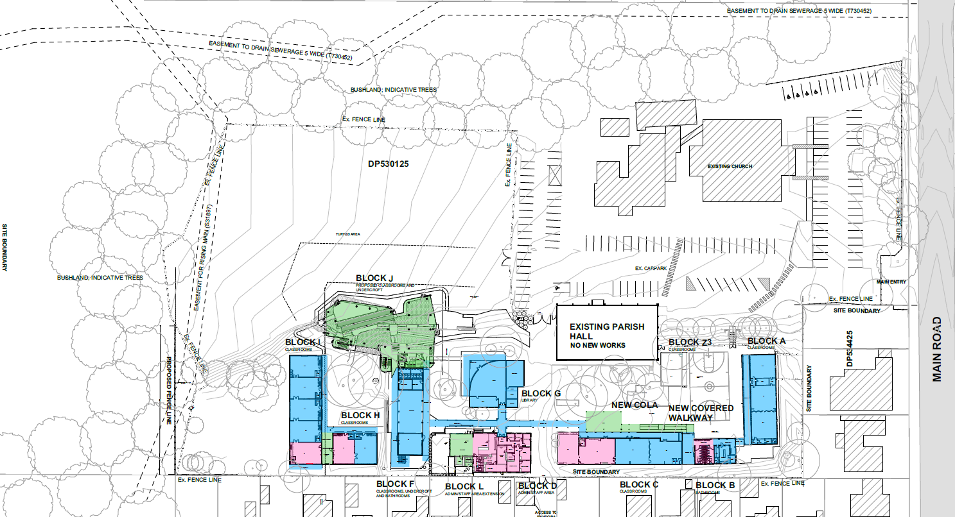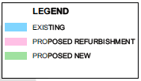
Figure 4. Proposed site plan.

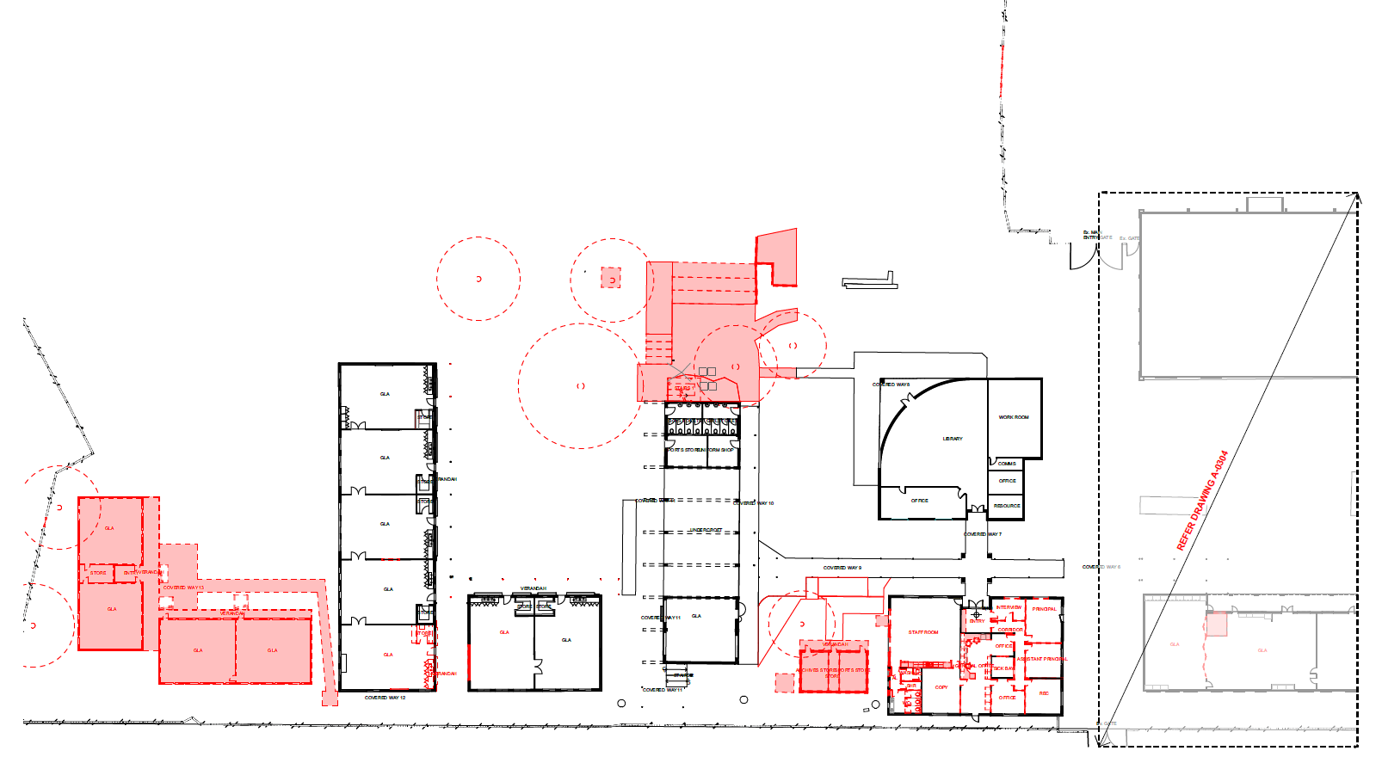
Figure 5. Demolition Plan

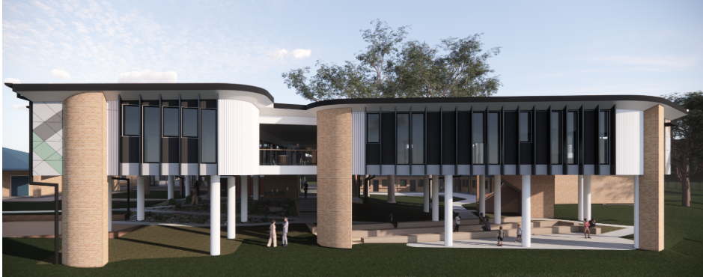
Figure 6. Artist’s Impression of New Building J.

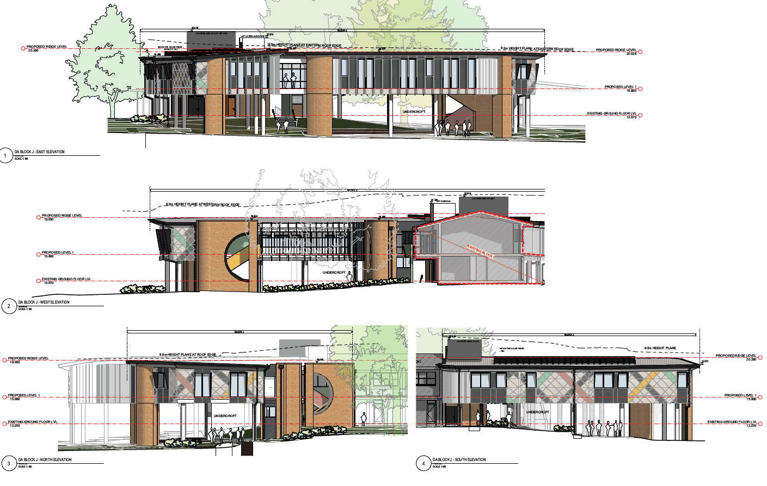
Figure 7. Building J Elevations

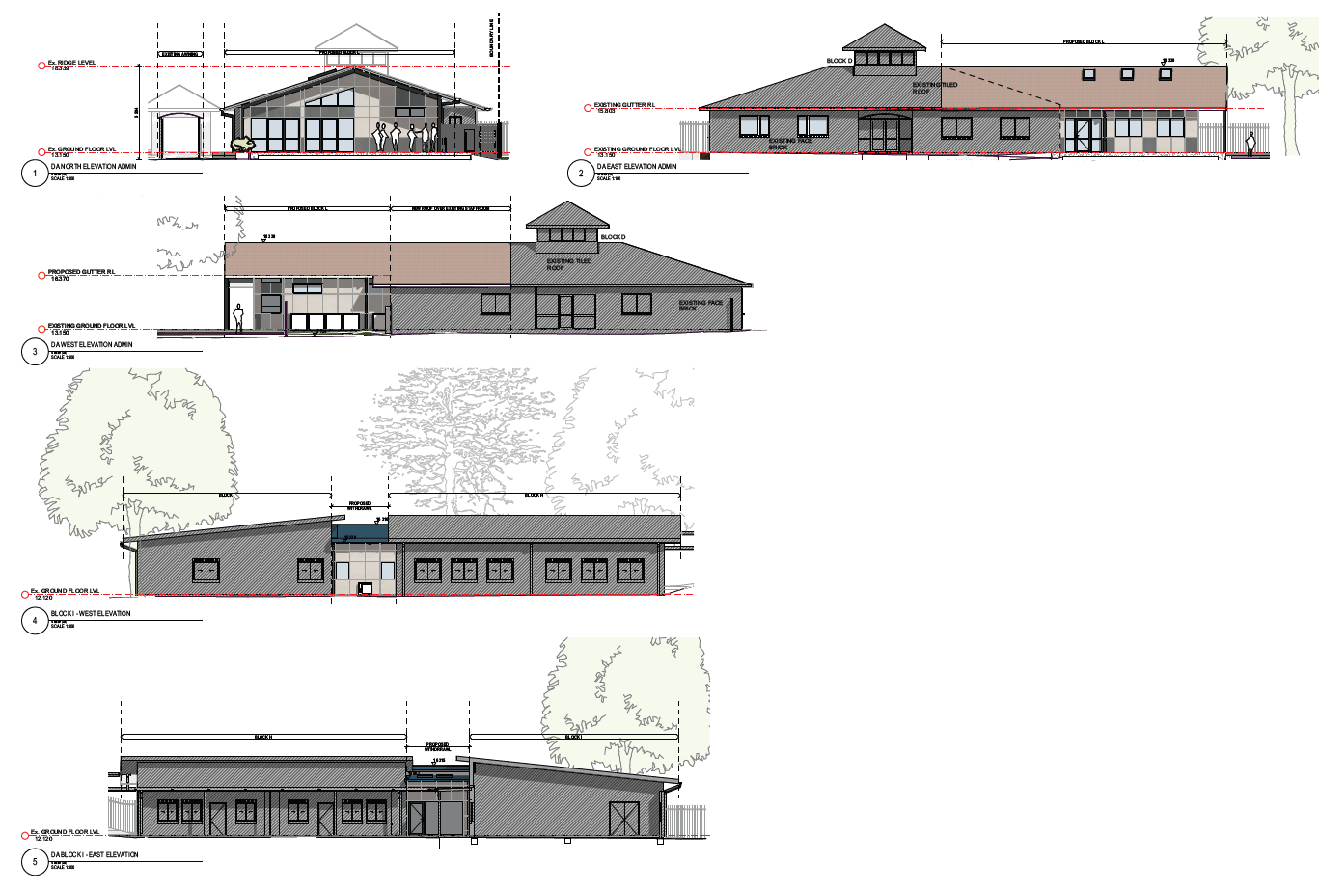
Figure 8. Elevations Awning and Block I.

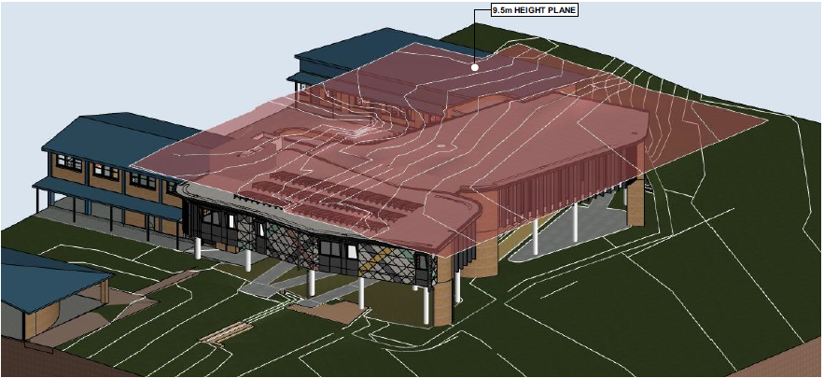Figure 9. Building J Building Hiehgt Standard Compliance Plane

BACKGROUND

The development application was lodged on the Planning Portal on 31 March 2023 and accepted by Central Coast Council on 6 November 2023.

A chronology of the development application since lodgement is outlined below including the Panel’s involvement with the application:

Table 2. Chronology of the DA

Date | Event
15 November 2023 | DA referred to external agencies
24 November 2023 | Exhibition of the application
4 December 2023 | Amended Plans Submitted
7 December 2023 | Advice received from TfNSW
16 January 2024 | Panel briefing
29 January 2024 | GTAs from NSW RFS received
19 March 2024 & 24 May 2024 | Site inspections for morning and afternoon peak.

SITE HISTORY

A search of Council’s electronic records show following applications were previously considered in relation to the subject site:

- DA-80/865: On 23 December 1980, Development Application No. DA-80/865 was approved, permitting the construction of a classroom.

- DA-81/677: On 6 November 1981, Development Application No. DA-81/677 was approved, permitting the installation of a demountable classroom.

- DA-82/202: On 14 May 1982, Development Application No. DA-82/1982 was approved, permitting the construction of a classroom and toilets for school purposes.

- DA-83/454: On 19 December 1983, Development Application No. DA-83/454 was approved, permitting classroom additions to the existing school.

- DA-86/307: On 4 September 1986, Development Application No. DA-86-307 was approved, permitting extensions to the Church.

- DA-87/281: On 17 July 1987, Development Application No. DA-87/281 was approved, permitting the relocation of two (2) transportable classrooms.

- DA-225/94: On 25 March 1994, Development Application No. DA-225/94 was approved, permitting access improvement works to the site.

- DA-866/96: On 18 October 1996, Development Application No. DA-866/96 was approved, permitting alterations to classrooms and the erection of an Administration Block.

- DA-2615/99: On 26 November 1999, Development Application No. DA-2615/99 was approved, permitting the construction of a new library building and relocation of demountables.

- DA/1008/2008: On 13 October 2008, Development Application No. DA/1008/2008 was approved, permitting the installation of water tanks.

- DA/826/2009: On 28 September 2009, Development Application No. DA/826/2009 was approved, permitting the construction of a single storey classroom block & alterations to existing.

- TA/343/2012: On 23 July 2012 TA/343/2012 was approved, permitting the removal of two trees.
STATUTORY CONSIDERATIONS

When determining a development application, the consent authority must take into consideration the matters outlined in Section 4.15(1) of the of the Environmental Planning and Assessment Act 1979 (‘EP&A Act’). These matters as are of relevance to the development application and include the following:

- the provisions of any environmental planning instrument, proposed instrument, development control plan, planning agreement and the regulations
(i) any environmental planning instrument, and
(ii) any proposed instrument that is or has been the subject of public consultation under this Act and that has been notified to the consent authority (unless the Planning Secretary has notified the consent authority that the making of the proposed instrument has been deferred indefinitely or has not been approved), and
(iii) any development control plan, and
(iiia) any planning agreement that has been entered into under section 7.4, or any draft planning agreement that a developer has offered to enter into under section 7.4, and
(iv) the regulations (to the extent that they prescribe matters for the purposes of this paragraph), that apply to the land to which the development application relates,
- the likely impacts of that development, including environmental impacts on both the natural and built environments, and social and economic impacts in the locality,
- the suitability of the site for the development,
- any submissions made in accordance with this Act or the regulations,
- the public interest.

These matters are further considered below.

ENVIRONMENTAL PLANNING INSTRUMENTS, PROPOSED INSTRUMENT, DEVELOPMENT CONTROL PLAN, PLANNING AGREEMENT AND THE REGULATIONS

The relevant environmental planning instruments, proposed instruments, development control plans, planning agreements and the matters for consideration under the Regulation are considered below.

SECTION 4.15(1)(a)(i) – PROVISIONS OF ENVIRONMENTAL PLANNING INSTRUMENTS

The following EPI’s are relevant to the application:

Table 3. Summary of applicable EPI’s:
EPI | Matters for Consideration | Comply (Y/N)
State Environmental Planning Policy (Planning Systems) | Chapter 2: State and Regional Development  Section 2.19(1) declares the proposal regionally significant development pursuant to Clause 5 of Schedule 6 as it comprises private infrastructure and community facilities over $5M. | Yes
State Environmental Planning Policy (Biodiversity and Conservation) 2021 | The proposed vegetation removal is not considered to be ecologically significant.  No koalas or koala habitat is affected or impacted by the proposed development. | Yes
State Environmental Planning Policy (Resilience and Hazards) 2021 | The site is located within a coastal environment and coastal use area and is deemed satisfactory with regards to Clauses 2.8, 2.11 and 2.12 of the SEPP.  The current and historic land uses are not potentially contaminating therefore the site is deemed satisfactory with regards to the relevant provisions of the SEPP and considered to be suitable for the continued use as an educational facility. | Yes
State Environmental Planning Policy (Transport and Infrastructure) 2021 | The proposed development fronts a classified road (Main Road MR509).  The development is a traffic generating development for the purposes of S2.121 however, being and educational establishment the development is also a traffic generating development under S3.58.  TfNSW has provided comment in accordance with S3.58 raising no objections or specific requirements with respect to the proposed development. | Yes
Proposed instruments | Not applicable in this instance. | N/A
CCLEP 2022 | Clause 2.3 – Permissibility and zone objectives | Yes
CCDCP | Chapter 2.13 – Transport and Parking  Chapter 2.14 – Waste Management  Chapter 2.17 – Character and Scenic Quality  Chapter 3.1 – Floodplain Management  Chapter 3.5 – Tree and Vegetation | Yes

Section 4.47 – Development that is Integrated Development (EP&A Act 1979)

The site is designated as Bushfire Prone Land as shown in the below figure.

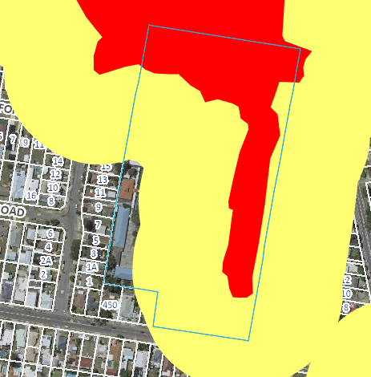
Figure 10. Extract from the Central Coast Council Bushfire Prone Land Map.

The subject development is a Special Fire Protection Purpose (SFPP) on bushfire prone land and is therefore classified as integrated development under Section 4.46 of the EP&A Act. The development is also captured under Section 100B of the Rural Fires Act 1997 and must obtain a Bush Fire Safety Authority from the Commissioner of the NSW Rural Fire Service.

Accordingly, the application is accompanied by a Bushfire Assessment Report, prepared by Building Code and Bushfire Hazard Solutions Pty Limited and dated 25 September 2023, which provides an independent bushfire assessment together with appropriate recommendations for both new building construction and bushfire mitigation measures considered necessary having regard to construction within a designated ‘bushfire prone area’.

In accordance with s.4.46(1) of the Environmental Planning and Assessment Act 1979, the development application and accompanying bushfire report were referred to the NSW Rural Fire Service seeking general terms of approval. The NSW RFS issued General Terms of Approval under Division 4.8 of the EP&A Act 1979 and a Bush Fire Safety Authority under section 100B of the Rural Fires Act 1997 was issued on Monday 29 January 2024, subject to recommended conditions.

Section 4.47, subsections (1), (2) and (3) of the EP&A Act 1979 state as follows:
4.47 Development that is integrated development

(1) This section applies to the determination of a development application for development that is integrated development.
(2) Before granting development consent to an application for consent to carry out the development, the consent authority must, in accordance with the regulations, obtain from each relevant approval body the general terms of any approval proposed to be granted by the approval body in relation to the development. Nothing in this section requires the consent authority to obtain the general terms of any such approval if the consent authority determines to refuse to grant development consent.
(3) A consent granted by the consent authority must be consistent with the general terms of any approval proposed to be granted by the approval body in relation to the development and of which the consent authority is informed. For the purposes of this Part, the consent authority is taken to have power under this Act to impose any condition that the approval body could impose as a condition of its approval.
Having regard for the above, the consent authority can be satisfied that General Terms of Approval have been obtained from the NSW Rural Fire Service (s.4.47(2)), and that the draft conditions of consent are consistent with the General Terms of Approval that have been granted.
State Environmental Planning Policy (Planning Systems) 2021

Chapter 2: State and Regional Development

The proposal is regionally significant development pursuant to Section 2.19(1) as it satisfies the criteria in Clause 5 of Schedule 6 of the Planning Systems SEPP as the proposal is development for the purposes of an educational establishment that has a capital investment value of more than $5 million. Accordingly, the Hunter and Central Coast Regional Planning Panel is the consent authority for this application.

The proposal is consistent with this Policy.

State Environmental Planning Policy (Resilience and Hazards) 2021

The relevant provisions of the SEPP are addressed as follows:

Chapter 2: Coastal Management

The aims of Chapter 2 are to be considered when determining an application within Coastal Management Areas.
The site is located on northern side of Main Road, Noraville and is bounded in the north and east by Toukley Wetlands. These wetlands are a coastal wetland for the purposes of the SEPP and the site is mapped as containing a portion of the wetland and areas of proximity area for coastal wetlands. The footprint of development is wholly outside of the wetland area and the development is not considered to be designated development however, Section 2.8 is to be taken into consideration with respect to the development occurring within the proximity area for coastal wetlands. A compliance table for s.2.8 of this SEPP has been included below.
Table 4. Section 2.8 – Development on land in proximity to coastal wetlands or littoral rainforest
Matters for Consideration | Compliance
(1) Development consent must not be granted to development on land identified as “proximity area for coastal wetlands” or “proximity area for littoral rainforest” on the Coastal Wetlands and Littoral Rainforests Area Map unless the consent authority is satisfied that the proposed development will not significantly impact on:
(a) the biophysical, hydrological or ecological integrity of the adjacent coastal wetland or littoral rainforest, or | The development is generally contained to the existing footprint of the school and disturbed area but will result in some removal of vegetation.  Council’s Ecologist is satisfied that the proposed tree removal nominated will not result in long lasting biodiversity impacts or contribute to fragmentation of the adjacent significant biodiversity habitat.  Clearing to facilitate APZ requirements will involve the management of primarily exotic species, with a dense shrub layer of Lantana camara present in the designated area.  It is expected that all the ecological impact mitigation measures outlined in the submitted Ecological Assessment Report (Anderson Environment and Planning, September 2023) are followed and Tree Protection recommendations outlined in the submitted Arboricultural Impact Assessment (Advance Treescape Consulting, September 2023) are implemented and adhered to.  The development is expected to largely maintain the status quo in relation to the hydrological impacts associated with the existing development.  The proposed development will not have a significant impact on the biophysical, hydrological or ecological integrity of the adjacent coastal wetland.
(b) the quantity and quality of surface and ground water flows to and from the adjacent coastal wetland or littoral rainforest. | The proposed works will create impervious areas principally with the inclusion of Block J however, the removal of the demountable classrooms will offset this increase thus maintaining a near-to existing stormwater discharge rate and impervious surfaces.  Water quality is similarly expected to maintain the water quality of discharge from the site with roof area vs landscape area largely maintaining the status quo.  It is noted that the existing demountable classrooms do not drain to a rainwater tank whereas the proposed Block J will be captured with the proposed 5,000 litre rainwater tank which should result in a minor improvement to water quality through the settlement of suspended solids and sediment latent nutrients.  The stormwater will be captured and conveyed through a network of pits and pipes in accordance with AS/NZS 3500.3 and discharged to the existing stormwater drainage system servicing the allotment.  The development will not have a significant impact on the quantity and quality of surface and ground water flows to and from the adjacent coastal wetland

The subject site is located within the coastal use area. Section 2.11 is to be taken into consideration by the consent authority when it determines a development application to carry out development on land within the coastal use area. The proposed development has satisfactorily addressed the matters for consideration outlined in s.2.11. A compliance table for s.2.11 of this SEPP has been included below.
Table 5. Section 2.11 – Coastal Use Area
Matters for Consideration | Compliance
(1) Development consent must not be granted to development on land that is within the coastal use area unless the consent authority:
(a) has considered whether the proposed development is likely to cause an adverse impact on the following:
(i) existing, safe access to and along the foreshore, beach, headland or rock platform for members of the public, including persons with a disability, | The site is not in proximity to public open space and does not impact existing safe access to and along the foreshore for members of the public
(ii) overshadowing, wind funnelling and the loss of views from public places to foreshores, | The more significant portion of new construction is centralised within the site and the proposal will not result in unreasonable overshadowing, wind funnelling or loss of views from any public places to foreshores.
(iii) the visual amenity and scenic qualities of the coast, including coastal headlands, | The proposal will not impact visual amenity or scenic qualities of the coastal area
(iv) Aboriginal cultural heritage, practices and places, | The proposal is not likely to cause an adverse impact on Aboriginal cultural heritage, practices and places.
(v) cultural and built environment heritage, and | The site is within a developed urban area and the proposed development is unlikely to adversely impact the cultural and built environment heritage.
(b) is satisfied that—
(i) the development is designed, sited and will be managed to avoid an adverse impact referred to in paragraph (a), or | The proposed development has been designed, sited to avoid any adverse impact referred to in paragraph (a).
(ii) if that impact cannot be reasonably avoided—the development is designed, sited and will be managed to minimise that impact, or | N/A
(iii) if that impact cannot be minimised—the development will be managed to mitigate that impact, and | N/A
(c) has taken into account the surrounding coastal and built environment, and the bulk, scale and size of the proposed development. | The proposed development has taken into account the surrounding coastal and built environment. The proposed bulk, scale and size of the development is demonstrated to be acceptable.

In accordance with section 2.12 the proposed development is not likely to cause any increased risk of coastal hazards on the subject site or adjoining lands, and there is no relevant certified coastal management program that needs to be considered as per s.2.13.

Having regard for Sections 2.8, 2.11 and 2.12 of State Environmental Planning Policy (Resilience & Hazards) 2021, the Panel can be satisfied that the proposed development is designed, sited, and will be managed to avoid; a significant impact on the integrity of the coastal wetland referred to in s.2.8(1) or an adverse impact referred to in S2.11(1). The bulk, scale and size of the proposed development is satisfactory having regard for the surrounding coastal and built environment (s.2.11(3)), and the development is not likely to cause increased risk of hazards on the subject site or other land (s.2.12).

Chapter 4: Remediation of Land

The provisions of Chapter 4 have been considered in the assessment of the development application and requires consent authorities to consider whether the land is contaminated, and if the land is contaminated, it is satisfied that the land is suitable in its contaminated state (or will be made suitable, after remediation) for the purpose for which the development is proposed to be carried out.

The site has historically been used as a school since 1973 and its past use is unlikely to have resulted in contamination of the site. The proposed works are generally within the footprint of the existing development comprising renovation and replacement of existing structures and the construction of a new building within an area currently utilised as part of the school.

A stage 1 preliminary site investigation prepared by EBG Environmental Geoscience dated 16 July 2023 has been submitted in support of the development application which investigates the site history and attributes to identify any past and present sources of potential contamination. The preliminary site investigation concludes that further stage 2 detailed site investigation is not required.

In accordance with s.4.6, the Panel can be satisfied that the land is suitable for the proposed development, a preliminary site investigation is not required in this instance and that based on information before council, the land has not been previously used for a purpose referred to in Table 1 of the contaminated land planning guidelines.

State Environmental Planning Policy (Transport and Infrastructure) 2021

Division 17 Roads and traffic

Section 2.119 Development with frontage to classified road

The proposed development fronts a classified road (Main Road MR509) and the consent authority must not grant consent to development on land that has frontage to a classified road unless it has considered the impact of the development on the classified road and the potential for noise and emission from the road to impact the proposed development.

In this instance the development is considered to have a satisfactory impact in relation to the classified road having regard to the matters specified in s.2.119(2). A compliance table for s.2.119(2) of this SEPP is included below.

Table 6. Section 2.119 Development with frontage to classified road
Matters for Consideration | Compliance
(2) The consent authority must not grant consent to development on land that has a frontage to a classified road unless it is satisfied that
(a) where practicable and safe, vehicular access to the land is provided by a road other than the classified road, and | The site does not have frontage to a road other than the classified road and there is no practical means of access other the classified road.
(b) the safety, efficiency and ongoing operation of the classified road will not be adversely affected by the development as a result of—
(i) the design of the vehicular access to the land, | The proposal does not involve any proposed changes to the existing access to the site. The existing access is considered to satisfactorily cater to the frequency and type of traffic accessing the site.
(ii) the emission of smoke or dust from the development | The operational phase of the development will not generate smoke or dust. The nature of the works proposed do not Any smoke or dust generated by construction works will be controlled
(iii) the nature, volume or frequency of vehicles using the classified road to gain access to the land, | The traffic impacts of the proposed development have been detailed in a Traffic Impact Assessment submitted in support of the development application prepared by TRAFFIX Traffic and Transport Planners. The modelling of the traffic impacts shows a minor increase to traffic on the the classified road which does not affect the level of service of the road or nearby intersections. The proposal has been assessed by Council’s Traffic and Transport Engineer and TfNSW neither of which have raised any objections to the development with regard to the impact on the safety and efficiency of classified road in terms of the nature, volume or frequency of vehicles resulting from the development.
(c) the development is of a type that is not sensitive to traffic noise or vehicle emissions, or is appropriately located and designed, or includes measures, to ameliorate potential traffic noise or vehicle emissions within the site of the development arising from the adjacent classified road. | The development application is supported by an Acoustical Assessment prepared by JHA Services dated 14/09/2023 which has considered the intrusive impacts of noise associated with the classified road. The Acoustical Assessment concludes that the new building will achieve an acceptable internal noise levels provided ‘an external glazing with a minimum sound reduction index of RW32 is required. A 6.38mm laminated fixed single glazing system achieves the nominated sound reduction index’. Subject to the development complying with the recommendations of the Acoustical Assessment the development is appropriately located and designed to ameliorate potential traffic noise.

Section 2.120 Impact of road noise or vibration on non-road development

Before determining a development application for development to which this section applies, the consent authority must take into consideration any guidelines that are issued by the Planning Secretary for the purposes of this section and published in the Gazette.

The development application is supported by an Acoustical Assessment prepared by JHA Services dated 14/09/2023 which considers the potential impacts of road noise on the development in the context of the NSW DECCW, Road Noise Policy (RNP) 2011. The Acoustical Assessment concludes that subject to the incorporation of suitable construction materials as mentioned above with respect to s.2.119 of this SEPP the development will not suffer from undue impacts associated with road noise. The development is not considered susceptible to vibration from the classified road. It is considered that the panel may be satisfied that the appropriate guidelines have been taken into consideration.

Section 2.122 Traffic-generating development

Before determining a development application for development to which this section applies, the consent authority must give written notice of the application to TfNSW within 7 days after the application is made and take into consideration any submission received within the specified period. In this instance TfNSW have provided comment indicating no objections are raised in relation to the development. The development is also considered to be a traffic generating development under s.3.58 of this SEPP which is addressed in the relevant area of this report below.

Chapter 3 Educational Establishments/Design Quality Principles

Section 3.11 of the SEPP requires consideration of Planning for Bush Fire Protection before carrying out the development in an area that is bush fire prone land.

In this instance, the site is identified as bushfire prone land due to the vegetation buffer at the rear. Further, Schools are listed as Special Fire Protection Purpose (SFPP) under s.100B(a) of the Rural Fires Act 1997. As previously discussed, the application was referred to the NSW RFS who have issued a Bushfire Safety Authority and General Terms of Approval for the proposed development.

Section 3.35 of the SEPP requires a consent authority to take into consideration the design quality of the development in accordance with the design quality principles set out in Schedule 8 of the SEPP. The seven design principles are set out in the following table.

Table 7. Design Quality Principles and Assessment
Design Quality Principle | Design Response | Compliance
Principle 1 - context, built form and landscape.  Schools should be designed to respond to and enhance the positive qualities of their setting, landscape and heritage, including Aboriginal cultural heritage. The design and spatial organisation of buildings and the spaces between them should be informed by site conditions such as topography, orientation and climate.  Landscape should be integrated into the design of school developments to enhance on-site amenity, contribute to the streetscape and mitigate negative impacts on neighbouring sites.  School buildings and their grounds on land that is identified in or under a local environmental plan as a scenic protection area should be designed to recognise and protect the special visual qualities and natural environment of the area and located and designed to minimise the development’s visual impact on those qualities and that natural environment. | The proposed elevated building, referred to as Block J, enhances the positive qualities of the school setting through its strategic placement. This new structure is intended to replace temporary student learning areas currently housed in demountable buildings on the lower northern side of the school, which is situated in a higher bushfire attack level area.  The new building, while providing a safer environment, still maintains its connection to the natural surroundings by bordering the field with views of the reserve to the east. The placement of the proposal is central to the school, ensuring a strong functional link with the existing buildings while also adhering to safe distances from identified fire hazards.  The building design responds to the existing topography by minimising the need for excavation and maintaining an appropriate floor level to seamlessly integrate with the existing school infrastructure. The elevated structure presents an opportunity to preserve the visual connection between the drop-off point and the school field, while also creating a covered amphitheatre space for school assemblies.  The building's orientation is carefully planned to make the most of natural light and ventilation. The eastern and western facades incorporate vertical louvres to manage solar exposure and ensure sufficient cross-ventilation. Furthermore, the proposed building's central location on the site ensures minimal impact on neighbouring properties. Landscape architects have developed plans that showcase how the school's outdoor areas will be enhanced through new planting, gathering spaces, pathways, and play areas adjacent to and beneath the new building.  This design maintains a strong connection with the existing sports field. The inclusion of feature trees and shrubs not only adds greenery and shade but also aligns with Bushfire control measures of the inner protection zone. | Yes
Principle 2 - sustainable, efficient and durable.  Good design combines positive environmental, social and economic outcomes. Schools and school buildings should be designed to minimise the consumption of energy, water and natural resources and reduce waste and encourage recycling.  Schools should be designed to be durable, resilient and adaptable, enabling them to evolve over time to meet future requirements. | The new building has been designed with fully integrated ESD (Environmental Sustainable Design) principles. These principles include maximizing both passive and active sustainable design strategies, utilising local, durable, and sustainable building materials wherever possible, reusing excavated material and demolished paving and brickwork as fill, and considering the building's longevity through high-quality design, materials, flexibility, and adaptability in how the spaces function.  The project incorporates the use of solar panels to offset its carbon footprint and captures rainwater for irrigation of landscaped areas. Existing demountable buildings will be reused off-site, while a detailed waste management plan encourages minimisation and recycling wherever possible.  The new building and alterations and additions are constructed with durable materials that require minimal maintenance. The design allows for easy reconfiguration of spaces to adapt to changing educational needs. | Yes
Principle 3 - accessible and inclusive.  School buildings and their grounds should provide good wayfinding and be welcoming, accessible and inclusive to people with differing needs and capabilities.  Note — Wayfinding refers to information systems that guide people through a physical environment and enhance their understanding and experience of the space.  Schools should actively seek opportunities for their facilities to be shared with the community and cater for activities outside of school hours. | The accessibility of the new school building has been thoroughly considered in consultation with a qualified access consultant, as evidenced in the accessibility report. Wayfinding has been clearly articulated within the built form, ensuring a natural and logical flow of spaces from the main entry into the pathways leading to the classrooms and other learning spaces, both through covered and uncovered walkways. A particular emphasis has been placed on ensuring fair and equitable access.  The elevation of the new building has successfully addressed the disconnect and dysfunction of the upper level of the existing two-storey building, expanding this area and providing a much-needed lift. This new lift, along with newly compliant walkways and thresholds, ensures compliance with all relevant regulations and standards.  This includes a compliant walkway in and around the undercroft area, for fair and equitable access to the field level. Thanks to the inclusive nature of the proposed building and the surrounding pathways, it can accommodate activities outside of school hours for the broader community. | Yes
Principle 4 - health and safety.  Good school development optimises health, safety and security within its boundaries and the surrounding public domain, and balances this with the need to create a welcoming and accessible environment. | The safety and security of the school community have been carefully considered, with a focus on enabling easy visual surveillance of both staff and students within the building. All learning spaces can be opened to adjacent areas, and even when closed, they maintain a visual connection through ample glazing.  The proposed WC area, which is open to the undercroft space, features public handwash areas as part of an anti-bullying design strategy. Existing fences have been retained and extended around the school, including the addition of a new fence to the north. This expansion is in line with the requirements outlined in the bushfire report, ensuring the maintenance of the asset protection zone. | Yes
Principle 5 - amenity.  Schools should provide pleasant and engaging spaces that are accessible for a wide range of educational, informal and community activities, while also considering the amenity of adjacent development and the local neighbourhood.  Schools located near busy roads or near rail corridors should incorporate appropriate noise mitigation measures to ensure a high level of amenity for occupants.  Schools should include appropriate, efficient, stage and age appropriate indoor and outdoor learning and play spaces, access to sunlight, natural ventilation, outlook, visual and acoustic privacy, storage and service areas. | The proposal provides pleasant and engaging learning spaces that offers flexibility to cater to diverse community needs. Various modes of learning can take place with the flexible design which caters to 21st century pedagogy of multi-modal learning. The spaces will also be used for staff meetings as well as for the wider school community. The shared learning areas will have flexible furniture and would suite various functions in particular. It will be a positive contribution to the local neighbourhood. Noise mitigation measures are considered and are outlined in the acoustic report. The building being situated away from neighbouring buildings means there’s negligible negative noise impact on the surrounding neighbourhood as demonstrated in the test results in the acoustic report.  The learning and play spaces are appropriate and efficient to cater to the various stages. The outlooks, natural light, and ventilation that the building is designed to take advantage of gives students and staff appropriate amenity in their day-to-day use of the space. | Yes
Principle 6 - whole of life, flexible and adaptive.  School design should consider future needs and take a whole-of-life-cycle approach underpinned by site wide strategic and spatial planning. Good design for schools should deliver high environmental performance, ease of adaptation and maximise multi-use facilities. | The school wide masterplan has been pre-considered to ensure the whole of life of the building is considered in conjunction with the functioning of the whole school. A significant feature of the design is the flexibility and adaptability of the spaces to futureproof the building and to extend the life of the building. The learning spaces are multi-purpose and can be used as individual smaller compartments or opened up to form several larger spaces in response to user requirements. The building provides environmental performance features with a focus on ESD principles and has spatial relationships which flow naturally and with ease. | Yes
Principle 7- aesthetics.  School buildings and their landscape setting should be aesthetically pleasing by achieving a built form that has good proportions and a balanced composition of elements. Schools should respond to positive elements from the site and surrounding neighbourhood and have a positive impact on the quality and character of a neighbourhood.  The built form should respond to the existing or desired future context, particularly, positive elements from the site and surrounding neighbourhood, and have a positive impact on the quality and sense of identity of the neighbourhood. | The building is aesthetically pleasing, utilizing materials and finishes that harmonize with the existing school, providing a timeless and subdued appearance. The palette incorporates natural tones to complement and enrich the existing context. Where touches of color are introduced, they are applied sparingly and playfully, reflecting the lively and joyful nature of a primary school.  The overall built form maintains a lightweight and unobtrusive appearance, seamlessly integrating with the landscape design that naturally extends beneath the building to the surrounding outdoor spaces. The tall gum trees in the vicinity prominently frame the school, and the new building fits unobtrusively within this nature-rich setting. Consequently, the identity of the new building aligns harmoniously with its surrounding context. | Yes

The development involves the increase in capacity of more than 50 students and therefore the consent authority must consult with TfNSW and take into consideration the matters contained in s.3.358(3). The consideration of the relevant matters is summarised in the table below.

Table 8. Section 3.58 Traffic-generating development
Matters for Consideration | Compliance
(3) The consent authority must take into consideration
(a) any submission that TfNSW provides in response to that notice within 21 days after the notice was given (unless, before the 21 days have passed, TfNSW advises that it will not be making a submission) | TfNSW has reviewed the information provided and raises no objection to or requirements for the proposed development as it is considered there will be no significant impact on the nearby classified (State) road network.  TfNSW included further advice to Council in its submission pursuant to s.3.58 which relate to the incorporation of appropriate construction traffic management, consideration of intersection sight lines and drainage. The conditions of consent adequately address the management of construction traffic and the existing access to the site is acceptable in terms of geometry and sight distances. The site drains away from the classified road and drainage of the road will be unaffected by the proposal.
(b) the accessibility of the site concerned, including
(i) the efficiency of movement of people and freight to and from the site and the extent of multi-purpose trips, | The proposal does not involve the movement of freight. The existing school is well serviced by buses and has good pedestrian connections including a signalised crossing of Main Road. The site is in proximity but not within the main commercial area of Toukley and there is limited potential for multi purposes trips associated with the existing school.
(ii) the potential to minimise the need for travel by car | The operational phase of the development will not generate smoke or dust. The nature of the works proposed do not Any smoke or dust generated by construction works will be controlled
(c) any potential traffic safety, road congestion or parking implications of the development. | The traffic impacts of the proposed development have been detailed in a Traffic Impact Assessment submitted in support of the development application prepared by TRAFFIX Traffic and Transport Planners. The modelling of the traffic impacts shows a minor increase to traffic on the the classified road which does not affect the level of service of the road or nearby intersections. The proposal has been assessed by Council’s Traffic and Transport Engineer and TfNSW neither of which have raised any objections to the development with regard to the impact on the safety and efficiency of classified road in terms of the nature, volume or frequency of vehicles resulting from the development. The development does not result in any undue traffic safety, road congestion or parking impacts.

State Environmental Planning Policy (Biodiversity and Conservation) 2021

Chapter 4: Koala habitat protection 2021

There is no approved koala plan of management which applies to the site and no koalas are recorded to have occurred on the site. In accordance with Section 4.9(3) of the Biodiversity Conservation SEPP 2021, the application is considered to have no impact on koalas or koala habitat.

Central Coast Local Environmental Plan 2022

The relevant local environmental plan applying to the site is the Central Coast Local Environmental Plan 2022 (CCLEP 2022).

Zoning and Permissibility

The site is zoned is R2 – Low Density Residential and C2 – Environmental Conservation pursuant to Clause 2.2 of the CCLEP 2022. The proposed works are wholly contained in the R2 zoned portion of the site.

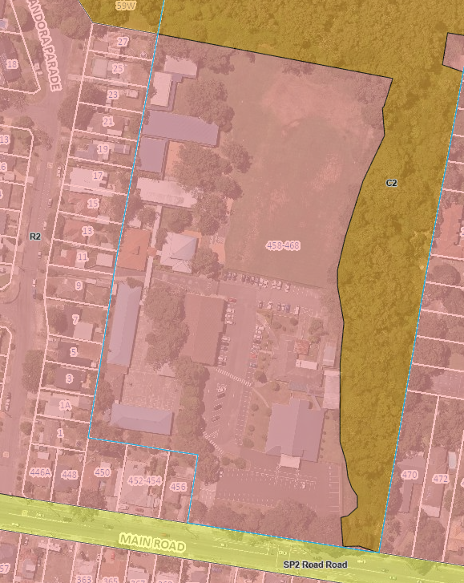
Figure 11. Land zoning map.

The proposed development satisfies the definition of ‘educational establishment’ which is a permissible use with consent in the Land Use Table in Clause 2.3.

The R2 zone objectives include the following, pursuant to the Land Use Table in Clause 2.3:

- To provide for the housing needs of the community within a low-density residential environment.
- To enable other land uses that provide facilities or services to meet the day to day needs of residents.
- To encourage best practice in the design of low-density residential development.
- To ensure that non-residential uses do not adversely affect residential amenity or place unreasonable demands on services.
- To maintain and enhance the residential amenity and character of the surrounding area.

The proposed development provides for alterations and additions to an existing, well established primary school that will have no impact upon the amenity, character, or services of the surrounding low density residential neighbourhood. A school is a facility that meets the day to day needs of residents and the proposed development reinforces that current use.

The C2 zone objectives include the following, pursuant to the Land Use Table in Clause 2.3:

- To protect, manage and restore areas of high ecological, scientific, cultural or aesthetic values.

- To prevent development that could destroy, damage or otherwise have an adverse effect on those values.

The proposed development avoids and minimising any impacts on the wetland area which is zoned C2 and in this regard the development is compatible with the objectives of the zone.

General Controls and Development Standards (Parts 2, 4, 5 and 6)

The CCLEP 2022 contains controls relating to development standards, miscellaneous provisions, and local provisions. The relevant controls to the proposal are further set out in Table 5 below.

Table 9. Consideration of LEP controls.
Control | Requirement | Proposal | Comply
Minimum subdivision lot size  (clause 4.1) | N/A | N/A | N/A
Height of Buildings (clause 4.3(2) | 9.5M | 9.3M | Yes
Floor Space Ratio  (clause 4.4(2) | 0.5:1 | 0.108:1 | Yes
Heritage  (clause 5.10) | N/A | N/A | N/A
Bushfire Hazard Reduction  (clause 5.11) | N/A | N/A | N/A
Flood Planning  (clause 5.21) | Development consent must not be granted to development on land the consent authority considers to be within the flood planning area unless particulars are demonstrated to be satisfied. | Discussed below. | Yes
Special Flood Considerations  (clause 5.22) | states that development consent must not be granted for an educational establishment unless the consent authority is satisfied that the development will not in flood events exceeding the flood planning level, affect the safe occupation of and evacuation from the land. | Discussed below. | Yes
Acid Sulfate Soils (clause 7.1) | Development consent is required for the carrying of works described in the table in subclause 7.1(2). | Discussed below. | Yes
Essential Services  (clause 7.6) | The following essential services remain available to the site – the supply of water, electricity, disposal and management of sewage, stormwater drainage, suitable vehicular access and the collection and management of waste. | Yes | Yes

Clause 5.21 – Flood Planning

The subject site is subject to flooding in event up to the PMF as depicted on the plan extract below.

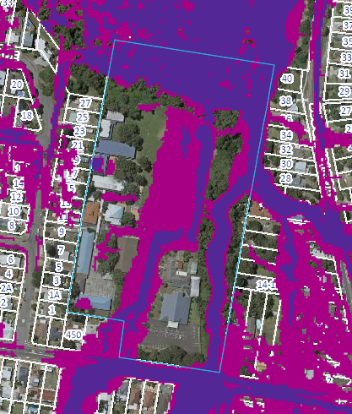
Figure 12. Flood prone land mapping indicating Probable Maximum Flood (PMF) Level

In accordance with Clause 5.21(2), development consent must not be granted to development on land the consent authority considers to be within the flood planning area unless the consent authority is satisfied the development –

- Is compatible with the flood function and behaviour on the land, and
- Will not adversely affect flood behaviour in a way that results in detrimental increases in the potential flood affectation of other development or properties, and
- Will not adversely affect the safe occupation and efficient evacuation of people or exceed the capacity of existing evacuation routes for the surrounding area in the event of a flood, and
- Incorporates appropriate measures to manage risk to life in the event of a flood, and
- Will not adversely affect the environment or cause avoidable erosion, siltation, destruction of riparian vegetation or a reduction in the stability of river banks or watercourses.

The application is accompanied by a Flood Risk Management Report prepared by JN Responsive Engineering dated 26/09/2023. The Assessment sets out flood advice detailing the flood constraints for the site and has been reviewed by Council’s Development Engineer who has confirmed that the proposed development is compatible with the flood function and behaviour on the land.

The finished floor level (15.92 m AHD) for the new building J is significantly higher than the PMF level of 11.23m AHD for critical and sensitive infrastructure such as the porposal which means the building will remain flood free. A safe low hazard evacuation route is available to the west to Pandora Avenue in the event of a flood emergency. The Flood Risk Management Report contains appropriate recommendations in relation to the use of flood compatible materials and the management of the school in relation to flood emergencies.

Council’s Development Engineer is satisfied that the proposal does not increase the risk to life or impact to the existing evacuation requirements and the design generally avoids impacting on flood behaviour, hence the proposal is supported. In this regard, the Panel can be satisfied that the proposed development, subject to conditions:
(a) is compatible with the flood function and behaviour on the land, and
(b) will not adversely affect flood behaviour in a way that results in detrimental increases in the potential flood affectation of other development or properties, and
(c) will not adversely affect the safe occupation and efficient evacuation of people or exceed the capacity of existing evacuation routes for the surrounding area in the event of a flood, and
(d) incorporates appropriate measures to manage risk to life in the event of a flood, and
(e) will not adversely affect the environment or cause avoidable erosion, siltation, destruction of riparian vegetation or a reduction in the stability of river banks or watercourses.

Clause 5.22 – Special Flood Considerations

An educational establishment is defined by clause 5.22 as a sensitive and hazardous development and pursuant to clause 5.22(2)(a) this clause applies to land that is above the flood planning level and below the PMF. In accordance with clause 5.22(3) development consent must not be granted to development on land the consent authority has considered whether the development -

(a) will affect the safe occupation and efficient evacuation of people in the event of a flood, and
(b) incorporates appropriate measures to manage risk to life in the event of a flood, and
(c) will adversely affect the environment in the event of a flood.

The flood assessment of the application has considered the implication of the PMF and found that the development is satisfactory in terms of the heads of consideration under clause 5.22, namely the development will not affect the safe occupation and efficient evacuation of people in a flood event, subject to the conditions of consent incorporates satisfactory measures to manage the risk to life in the event of a flood and will not adversely affect the environment in the event of a flood. The Panel can be satisfied the provisions of clause 5.22 have been met.

Clause 7.1 – Acid Sulfate Soils

The site is identified as Class 5 Acid Sulfate Soils and the application is accompanied by an Acid Sulfate Soil Assessment prepared by EBG Environmental Geoscience dated 18 July 2021. The Acid Sulfate Soil Assessment involved a review of site conditions and bores with no potential acid sulfate soil being detected down to a depth of 4.0m and as a result of the investigation and assessment carried out by the consultant it is considered that an Acid Sulfate Soil Management Plan (ASSMP) as defined within the Acid Sulfate Soil Manual (NSW ASSMAC August 1998) is not considered necessary. The panel may be satisfied that further assessment is not required under clause 7.1 pursuant to clause 7.1(4).

Clause 7.6 -Essential Services

The consent authority can be satisfied that the proposed development has adequate essential servicing available to the development having regard for water, sewer, electricity, stormwater drainage, waste collection and vehicular access.

SECTION 4.15(1)(a)(ii) – PROVISIONS OF ANY PROPOSED INSTRUMENTS

There are no draft instruments for consideration in this regard.

SECTION 4.15(1)(a)(iii) – PROVISION OF ANY DEVELOPMENT CONTROL PLAN

Central Coast Development Control Plan 2022

Chapter 2.13 - Transport and Parking

Table 10. Chapter 2.13 – Transport and Parking Summary of Considerations
Clause |  | Required | Comment | Compliance
2.13.3 |  | A traffic management plan is required where a variation to carparking is proposed. | The proposal retains 130 on-site spaces and parking survey shows that the quantum of street parking available (as permitted by the DCP) provides compliant car parking numbers. | Yes
 |  | A construction management plan is required while work is being carried out on site. | To be imposed as a condition of consent. | Yes
2.13.3.2 |  | Carparking – educational establishments. | The proposal will result in an increase in the number of students and a loss of 3 on-site parking spaces however, the development is considered to provide a compliant quantum of parking. | Yes
2.13.3.7 |  | Parking and access for the disabled. | 5 accessible spaces are to be provided on site existing on-site accessible space provided. Discussed below. | No – discussed below.

Roads, access, traffic and parking

The application is supported by Traffic Impact Assessment prepared by TRAFFIX Traffic and Transport Planners which examines the existing and proposed parking, access and traffic generation associated with the development. The following description of the existing road environment is provided within the Traffic Impact Assessment.

Central Coast Highway: a TfNSW Highway (HW 30) that generally runs in a north-south direction between the intersection of the Pacific Highway at Doyalson in the north and the Pacific Highway and Wisemans Ferry Road in the south. In the vicinity of the site, it is subject to a 60km/h speed zoning and provides a single traffic lane in each direction. Kerbside parking is generally not permitted along Central Coast Highway within the vicinity of the site.

Main Road: a TfNSW Main Road (MR 509) that generally runs in an east-west direction between the Central Coast Highway in the east and the Sydney-Newcastle Freeway in the west. In the vicinity of the site, it is subject to a 50km/h speed zoning, with 40km/h speed zoning during school zone times and provides a single lane of traffic in each direction. Unrestricted kerbside parking is generally permitted along Main Road within the vicinity of the site.

Pandora Parade: a local road that runs in a north-south direction between Birriga Road in the north and Main Road in the south. In the vicinity of the site, it is subject to a 50km/h speed zoning with 40km/h speed zoning during school zone times and permits two-way traffic movements. Unrestricted kerbside parking is generally permitted along both sides of the road.

The site is conveniently located with respect to the local and arterial road systems serving the region, with connections to the north and south via Central Coast Highway and connections to the west via Main Road.

The proposed development does not seek to alter the existing access arrangements for the site – both for pedestrians or vehicles including parking arrangements for 130 parking spaces including 5 accessible spaces, bus accommodations and servicing arrangements. The DCP parking rates require the provision of 135 parking spaces associated with the school however, the DCP makes provision for street parking to be included in the calculation of the parking provision. A parking survey carried out by the traffic consultant indicates an availability of 39 spaces in the morning peak and 40 in the afternoon which is considered to provide adequate on-site parking and the development is considered to provide a compliant quantum of parking.

The site inspections revealed that an informal access to the site exists over No. 11 Pandora Parade with a driveway connecting the subject site and Pandora Parade which was utilised as a pedestrian access to the subject site. There was a significant number of errantly parked vehicles observed during site inspections in proximity to No.11 Pandora Parade associated with the pedestrian traffic generated by the school. While No.11 Pandora Parade is held in the same ownership as the subject site it does not form part of the current application and it is considered that a condition of consent should prevent the use of No.11 Pandora Parade for pedestrian access to the school to alleviate the current desire point.

The site contains an existing church which generates the need for 50 on-site parking spaces however, the church pre-dates the erection of the school on the site and the two uses have enjoyed a shared use arrangement to avoid conflicts in the use of the parking and this is intended to continue unaffected by the proposed development.

Chapter 2.14 – Waste Management

A Waste Management Plan has been submitted for the demolition and construction stages of the proposed development in accordance with the requirements of this Chapter.

The provisions of this Chapter are satisfied in this regard.

Chapter 3.1 – Floodplain Management

The development is located on land within precinct 1 as described by the DCP and in accordance with clause 3.1.4.1 the development application must be supported by a report by a professional engineer who specialises in floodplain management and a professional engineer who specialises in civil engineering to certify that the development provides the matters specified in clause 3.1.4.1(3).

The subject site is subject to flooding and the application is accompanied by a Flood Risk Management Report prepared by JN Responsive Engineering dated 26/09/2023. A summary of the considerations under clause 3.1.4.1(3) is included below.

Table 11. Clause 3.1.4.1 Summary of Considerations
Matters for Consideration | Compliance
(a) Minimum floor levels = PMF level plus mine subsidence allowance, if applicable. | The smaller additions to existing structures are generally located in the west of the site and significantly higher than the flood affected areas through the sports field and carpark, these will be built at existing building levels and are beyond the Flood Precinct 1: Probable Maximum Flood extents.  The main new Block J had an undercroft external area at grade however all proposed classrooms are to tie-in with the first floor level of the adjacent existing building at RL 15.92.  The site is not within a Mine Subsidence Area.
(b) Low flood hazard access and egress for pedestrians during a PMF flood to an appropriate area of refuge located above the PMF. | The majority of the western side of the site is significantly higher than the primarily flood affected sports field and carpark. The smaller additions are within this area and the main new Block J is outside of PMF extents with a floor levels significantly above the adjacent PMF level.
(c) Low flood hazard emergency vehicle road access (Ambulance, SES, RFS) during a PMF flood event. | There is an existing vehicle gate on the western boundary of the site that leads via laneway to Pandora Parade and is clear of PMF extents south up to the intersection with Main Road,
(d) Consideration of the impacts of climate change. | The main new Block J has a floor level approximately 4.5m above the adjacent PMF levels, this would be expected to beyond the range of impact of Climate Change.

Subject to compliance with the recommendations of the Flood Risk Management Report the proposal is considered to satisfactorily meet the considerations under chapter 3.1 of the DCP.

Chapter 3.5 – Trees and Vegetation

The application is accompanied by an Arboricultural Impact Assessment, provided by Advance Treescape Consulting, dated September 2023. The development proposes the removal of eight trees. Two trees are of low retention value, four trees are considered to be medium retention value and two trees are considered to be high retention value.

The Report and associated documentation were referred to Council’s Tree Assessment Officer who has reviewed its content and agreed and confirmed that the eight trees located in the proposed works footprint require removal and that trees to be retained may be appropriately protected during works. Council’s Ecologist reviewed the proposed tree removal and does not expect the works to result in fragmentation or result on ongoing ecological impacts. Subject to the conditions of consent regarding tree protection measures it is considered that proposed tree impacts are acceptable.

SECTION 4.15(1)(a)(iiia) – PLANNING AGREEMENTS UNDER SECTION 7.4 OF THE EP&A ACT

There are no planning agreements or draft planning agreements entered into or proposed for the site. No further consideration is required in this regard.

SECTION 4.15(1)(a)(iv) – PROVISIONS OF REGULATIONS

Section 61 of the Environmental Planning and Assessment Regulation, 2021, contains matters that must be taken into consideration by a consent authority in determining a development application, with the following matters relevant to the proposal:

- If demolition of a building is proposed, provisions of AS2601 apply.

The proposed development includes the following:

- The proposed works involves minor internal and external demolition works to existing classroom and administrative buildings.
- A storage shed (Block E) is also proposed to be demolished to facilitate the extension of the Admin/Staff building.
Section 62 (consideration of fire safety) and Section 64 (consent authority may require upgrade of buildings) of the 2021 EP&A Regulation are not relevant to the proposal.

The provisions of the 2021 EP&A Regulation have been considered and are addressed in the recommended draft conditions.

SECTION 4.15(1)(b) – LIKELY IMPACTS OF DEVELOPMENT

The likely impacts of that development, including environmental impacts on both the natural and built environments, and social and economic impacts in the locality must be considered. In this regard, potential impacts related to the proposal have been considered in response to SEPPs, LEP and DCP controls outlined above and the Key Issues section below.

The consideration of impacts on the natural and built environments includes the following:

- Context and setting – The proposal is considered generally consistent with the context of the school site, in that the proposed building is an appropriate scale, mass, form, and in character with existing and surrounding development. The development is located central to the site in a location that will have a limited connection to the boundaries and nearby residential development. The development will have a negligible impact on the existing streetscape and character of the development when viewed from the public domain.

- Public Domain – The proposal will not impact the public domain. There is no public open space adjoining the site except for public road system.

- Utilities – All utilities are available to the site.

- Heritage – The site and adjoining lands do not contain any heritage items.

- Water, soil and air impacts – the site has been used as an educational establishment since the 1970’s and this past use is unlikely to result in contamination.

- Flora and fauna impacts – The application is accompanied by suitable Aboricultural and Ecological assessment reports that have been the subject of review by Council’s experts who have found the development to be acceptable subject to recommended conditions of consent.

- Noise and vibration – The application is accompanied by an Acoustic Assessment which considered the impacts of noise generated by the development on the receiving environment in addition to the potential intrusive effects of noise on the development from the nearby classified road and recommends measures for noise mitigation within the school. The proposed development can satisfy best practice standards, having no unreasonable noise impacts to the surrounding residential dwellings.

- Natural hazards – The site is considered bushfire prone and the development is defined as a Special Fire Protection Purpose under section 100B(a) of the Rural Fires Act 1997. The application is accompanied by a Bushfire Assessment Report, which was referred to the NSW RFS who have issued General Terms of Approval requiring appropriate construction, hazard management access and emergency procedures to be in place to address the bushfire risk.

The site is impacted by flooding however, the proposed development has been designed to be flood free and subject to the recommendations of the flood report submitted in support of the development application the development will adequate address the flood hazard associated with the site.

- Safety, security and crime prevention - Principles of CPTED have been considered by the applicant in the preparation of the development and in general the existing territorial controls, target hardening, and surveillance implemented by the existing school will carry forward to serve the proposed development.

- Social impact – The proposed development will enable the existing primary school to undergo a timely renewal and upgrade, to ensure that existing and future generations within the locality and broader Central Coast community have opportunities to high quality education. The proposal will replace aged and temporary facilities with contemporary learning facilities, resulting in positive social and economic outcomes.

- Economic impact – The proposed development will generate additional construction employment opportunities, having some local benefit for local businesses.

- Construction – All works on site will be carried out in accordance with statutory construction hours. A CMP will be required and is imposed as a condition of consent that mitigates internal and external impacts during construction.

- Cumulative impacts – The proposed development is unlikely to have any undue cumulative impacts. In the context of the site, it is consistent with applicable planning controls, zoning of the land and the objectives of the R2 – Low Density Residential Zone.

Accordingly, it is considered that the proposed development will not result in any significant adverse impacts in the locality as outlined above.

SECTION 4.15(1)(c) – Suitability of the site

The proposed development fits within the locality of the existing school. There are adequate services, public transport, on-site parking, and outdoor playing areas. The risk of bushfire from the adjoining vegetation buffer is mitigated by construction standards and conditions imposed by the NSW RFS.

There are no adjoining land uses which impact upon the development and the surrounding land uses are compatible with the school use.

SECTION 4.15(1)(d) – PUBLIC SUBMISSIONS

The proposal was notified in accordance with the DCP from 24 November 2023 until 18 December 2023. A total of one unique submission, comprising an objection was received. The issues raised in the submission are indicated below:

- The extent of written notification to adjoining and adjacent owners is not reflective of the scale and nature of the development and further written notification should have been undertaken.
- The length of time provided to review the extensive array of documents is not sufficient to enable a review and submission to be prepared.

Attempts to contact the submitter were unsuccessful and no further submissions were received raising matters related to the merits of the development. The application was notified in accordance with CCDCP 2022, Chapter 1.2 Notification of Development Proposals with regard to adjoining properties and notification period.

SECTION 4.15(1)(e) – PUBLIC INTEREST

Approval of the proposed development is in the public interest for the following reasons:

- The proposed development has been prepared having regard to the aims and objectives of Chapter 3: Education and Childcare contained within SEPP (Transport and Infrastructure) 2021 and other State and local environmental planning instruments and generally complies.

- Subject to various mitigation measures recommended by consultants and Council’s technical experts, the proposal is deemed to have no negative environmental, social, or economic impacts to surrounding residential dwellings or the public domain.

- The proposed development will result in a high-quality educational environment for students and teachers alike, that supports and provides efficient and environmentally sustainable facilities.

- The proposed development is designed and sited to make a positive contribution having regard to the landscaped setting in which the site exists.

- The proposed development remains sympathetic to the existing character of the surrounding residential neighbourhood and respects and maintains privacy to and from neighbouring residential properties.

- The proposed development is considered to offer a safer environment for residents as the design offers better passive surveillance over the public domain.

REFERRALS AND SUBMISSIONS

Agency Referrals and Concurrences

The application was referred to various agencies for comment/concurrence as required by the EP&A Act:

Table 11. Agency Consultation and Concurrence
Agency | Concurrence/  referral trigger | Comments  (Issue, resolution, conditions) | Resolved
Concurrence Requirements (s4.13 of EP&A Act)
N/A
Referral/Consultation Agencies
Transport for NSW | S2.122 & S3.58 – Traffic-generating development – SEPP T&I | No objections raised or conditions imposed. | Yes
Integrated Development (S 4.46 of the EP&A Act)
RFS | S100B - Rural Fires Act 1997  Bushfire Safety Authority required as the development comprises a Special Fire Protection Purpose. | GTAs Issued. | Yes

There are no outstanding issues arising from these concurrence and referral requirements, subject to the imposition of recommended conditions of consent.

Council Officer Referrals

The development application has been referred to various Council officers for technical review as outlined in the table below.

Table 12. Council Officer Referrals
Officer | Comments | Resolved
Engineering | No objections subject to conditions of consent. | Yes
Traffic | No objections to the development and no specific requirements recommended. | Yes
Contributions | No objections subject to condition requiring payment of contributions | Yes
Water and Sewer | No objections raised. Sufficient capacity within existing infrastructure. | Yes
Waste | No objection subject to compliance with the submitted waste plan. | Yes
Ecology | No objections subject to conditions of consent. | Yes
Trees | No objections to proposed tree removal subject to conditions | Yes
Environmental Health | No objections subject to conditions of consent requiring any food preparation areas to meet the relevant Australian Standards. | Yes

CONCLUSION

This development application has been considered in accordance with the requirements of the EP&A Act and the Regulations, as outlined in this report. The following is a summary of prerequisite conditions for the granting of development consent that have been considered in the assessment report and provided as part of the conclusion, for the benefit of the Panel:

- The Panel can be satisfied that the relevant General Terms of Approval have been obtained from the NSW Rural Fire Service in accordance with section 4.47(2) of the Environmental Planning and Assessment Act, 1979, and that the recommended conditions of consent are consistent with the General Terms of Approval in accordance with section 4.47(3) of the Environmental Planning and Assessment Act, 1979.

- In accordance with Chapter 4, section 4.9(2) of the State Environmental Planning Policy (Biodiversity and Conservation) 2021, the Panel can be satisfied that the development will have no impacts upon koalas or koala habitat.

- Having regard for Sections 2.8, 2.11 and 2.12 of State Environmental Planning Policy (Resilience & Hazards) 2021, the Panel can be satisfied that the proposed development is designed, sited, and will be managed to avoid an adverse impact referred to in s.2.8(1) and s.2.11(1), and the development is not likely to cause increased risk of hazards on the subject site or other land.

- The Panel can be satisfied that the land is suitable for the proposed development and does not include land referenced in section 4.6(4) of the State Environmental Planning Policy (Resilience and Hazards) 2021 nor does it involve a change of use of the land. Accordingly, the development is satisfactory having regard for the provisions of section 4.6 of the same SEPP.

- Having regard for the prerequisite conditions to the granting of consent under the Central Coast Local Environmental Plan 2022, the Panel can be satisfied that:

  - Clause 5.21 – Flood Planning

The proposed development:

- Is compatible with the flood function and behaviour on the land, and
- Will not adversely affect flood behaviour in a way that results in detrimental increases in the potential flood affectation of other development or properties, and
- Will not adversely affect the safe occupation and efficient evacuation of people or exceed the capacity of existing evacuation routes for the surrounding area in the event of a flood, and
- Incorporates appropriate measures to manage risk to life in the event of a flood and
- Will not adversely affect the environment or cause avoidable erosion, siltation, destruction of riparian vegetation or a reduction in the stability of riverbanks or watercourses.

  - Clause 5.22 – Special Flood Considerations

The proposed development:

(a) will not affect the safe occupation and efficient evacuation of people in the event of a flood, and
(b) does incorporate appropriate measures to manage risk to life in the event of a flood, and
(c) will not adversely affect the environment in the event of a flood.

  - Clause 7.6 – Essential services

All services essential for the proposed development remain available to the subject site.

RECOMMENDATION

That Development Application No. DA/2036/2023 for the alterations and additions to the existing educational establishment, being St Mary’s Catholic Primary School, at 458-468 Main Road, Norraville NSW, be APPROVED pursuant to Section 4.16(1)(a) of the Environmental Planning and Assessment Act 1979 subject to the draft conditions attached to this report at Attachment A.

The following attachments are provided:
- Attachment A – Draft Conditions of Consent
- Attachment B – Architectural Plans
- Attachment C – NSW Rural Fire Service General Terms of Approval
- Attachment D – Correspondence – Transport for NSW

